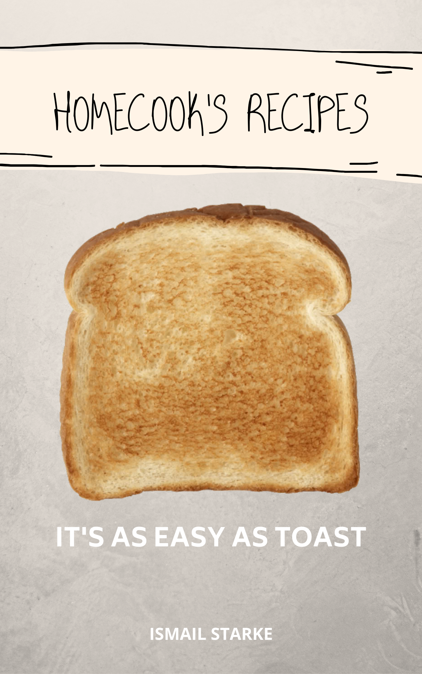

Contents

Curries 3

Pasta 7

Desserts 11



# Curries

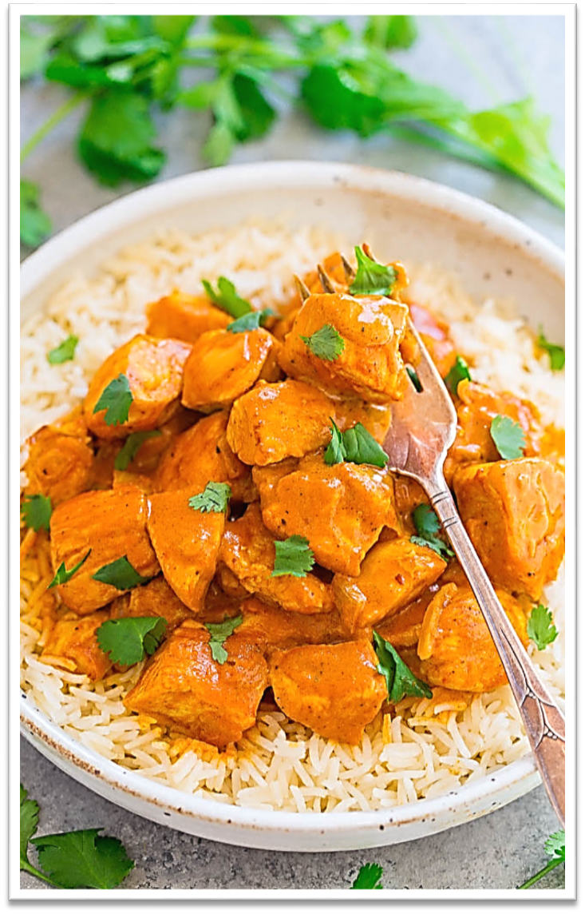

|  |  |  |
| --- | --- | --- |
| Butter Chicken | | |
| SERVES 4 – 5 | 1 – 2 HRS | | |
| **INGREDIENTS:** | **INSTRUCTIONS:** | |
| Chicken Breasts (Cubed) | | 1. Add all the marinade ingredients into a bowl with the chicken, mix well, and let it sit for 30 minutes or longer. The longer it sits, the better the flavour! 2. Finely dice two large onions. 3. In a medium sized pot, add 1 tbsp. oil for frying and the marinated chicken. Once the chicken is cooked, set aside and prepare for the next step. 4. Finely dice two large onions. 5. In the same pot you used for frying the chicken, add another tablespoon of oil, 1-tablespoon butter and the diced onion. 6. Add garlic and ginger paste, 3 chillies, salt, coriander powder, cumin, garam masala and water. 7. While the onions are braising, roughly chop three small tomatoes and add the chopped tomatoes and cashews once onions are golden brown. 8. Once the tomatoes have softened and become mushy, move what is in the pan to a blender and let it cool. 9. Once it has cooled down, blend the ingredients to a paste. 10. Back in the pot, add your sauce ingredients. First, the butter and Kashmiri chilli powder and once the butter starts to bubble add your paste and stir well. After you have stirred all your ingredients together, add your chicken. 11. While the paste is bubbling, add $\frac{3}{4}$ cup of fresh cream and your turmeric. Mix well. | |
| 1 Tbsp. Butter | |
| 1 Tbsp. Fish Oil | |
| 2 Onions (Finely diced) | |
| 1 tsp Ginger & Garlic Paste | |
| 3 Tomatoes (Roughly chopped) | |
| 3 Chillies (Finely chopped) | |
| 1 tsp Salt | |
| $\frac{1}{2}$ Coriander Powder | |
| 1 tsp Cumin | |
| 1 tsp Garam Masala  1 tsp turmeric | |
| 2 Tbsp. Water | |
| 10 Cashews | |
|  | |
| **Marinade:** | |
| 1 tsp Garlic & Ginger Paste | |
| 2 tsp Plain Yoghurt | |
| 1 tsp Kashmiri Chilli Powder | |
| $\frac{1}{2}$ tsp Garam Masala | |
| $\frac{1}{2}$ tsp Salt | |
| Juice of $\frac{1}{2}$ Lemon | |
|  | |
| **Sauce:** | |
| 2 Tbsp. Butter | |
| 1 tsp Kashmiri Chilli Powder | |
| Paste (Refer to instruction 9) $\frac{3}{4}$ cup Fresh cream | |

|  |  |
| --- | --- |
| Chicken Curry (inspired by Tasnim Pitamber) | |
| SERVES 4 – 5 | 1 – 2 HRS | |
| **INGREDIENTS:** | **INSTRUCTIONS:** |
| 1 kg Chicken (Preferably thighs and drumsticks) | 1. Finely dice two large onions. 2. In a large pot on high heat, add 2 tbsp. oil. It is important for your pan to be hot else by adding oil to a cold pan, as the pan heats up your oil burns away. 3. After adding your oil, throw in your diced onion. 4. Using the broad side of your knife, softly bang onto the cardamom pods to release all its flavour. You can also use the tip of the knife to open your star anise a little bit. 5. Now add your cinnamon sticks, cardamom pods, star anise, cloves, finely chopped chillies, garam masala, roasted masala, and chilli powder, and Kashmiri chilli powder, turmeric and ginger and garlic paste. Mix well. 6. While the onions braise, roughly chop your tomatoes and add it to the onions. Whenever the pot starts to dry up, add 2 tbsp. of water. 7. Once the tomatoes have softened and become mushy, add half a cup of water, and your chopped potatoes. Use the tip of your knife to poke holes into your potatoes allowing the flavour to be absorbed into the potatoes and so that the potatoes can cook from the inside making it beautifully soft. 8. Now add your chicken and cook everything until completion. |
| 2 Tbsp. Fish Oil |
| 2 Onions (Finely diced) |
| 3 Tomatoes (Roughly chopped) |
| 4 Potatoes (Chopped to your preferable size) |
| 3 Chillies (Finely chopped) |
| 2 Cinnamon sticks |
| 3 Cardamom pods |
| 2 Star Anise |
| 3 Cloves |
| 2 tsp Garam Masala  1 tsp Roasted Masala |
| 2 tsp Chilli Powder |
| 1 tsp Kashmiri Chilli Powder |
| $\frac{1}{4}$ tsp Turmeric |
| 1 tsp Garlic & Ginger Paste |
| Salt to taste |

|  |  |
| --- | --- |
| Cape Malay Soesys Kos | |
| SERVES 4 – 5 | 1 – 2 HRS | |
| **INGREDIENTS:** | **INSTRUCTIONS:** |
| Sausage | 1. Finely dice two large onions. 2. In a large pot on high heat, add 2 tbsp. oil. It is important for your pan to be hot else by adding oil to a cold pan, as the pan heats up your oil burns away. 3. After adding your oil, throw in your diced onion and braise. 4. Add your garlic, roasted masala, leaf masala, cumin powder, turmeric, chilli flakes, chilli powder and chillies. Add water as needed. 5. Once the onions have turned golden brown, add potatoes and water as needed. You may use the tip of your knife to poke holes into the potatoes, so that the potatoes may cook faster and they can absorb more flavour. 6. Once the potatoes are soft, add your sausage. 7. When the potatoes are just about cooked, add a tin of baked beans |
| Potatoes (Cut into quarters) |
| 1 Chilli |
| 2 tsp Roasted Masala |
| 2 tsp Leaf Masala |
| 1 tsp Cumin Powder |
| ½ tsp Turmeric |
| ½ tsp Chilli Flakes |
| ½ tsp Chilli Powder |
| Salt to taste |
| Add water as needed |
| 1 tin of Baked Beans |
|  |
|  |
|  |
|  |

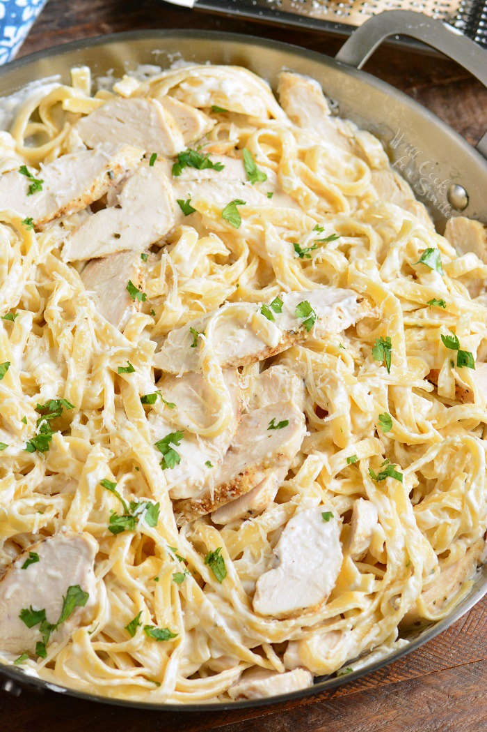

# Pasta

|  |  |
| --- | --- |
| Chicken Alfredo | |
| SERVES 4 – 5 | 1 – 2 HRS | |
| **INGREDIENTS:** | **INSTRUCTIONS:** |
| 1 kg Chicken breasts | 1. Fill a large pot with enough water to cook the pasta. Once the water has been brought to a boil, add salt and oil. 2. You may prepare your sauce while the pasta is cooking so that the sauce and pasta are completed around the same time. 3. Thinly slice your mushrooms. 4. Finely dice one large onion. 5. Mince your garlic. This is not necessary if you have a paste. 6. Slice the chicken breast into strips or cubes, depending on your preference and season with salt and pepper. 7. In a large, deep pan, add 2 tbsp. oil and throw your chicken in to cook it. 8. Remove the chicken from the pan and set aside. 9. In the same pan, add 1 tbsp. oil and 1 tbsp. butter, as well as your diced onion. Do not clean your pan out. Leave that flavour of the chicken behind for your sauce to cook in. 10. Sauté the onions until golden brown, and then add your mushrooms and continue to sauté. 11. Stir often. 12. When your mushrooms have turned golden brown, add your garlic and milk. Bring to a soft boil. 13. Once the milk has barely begun to thicken, add your cooked chicken and season the sauce with salt and pepper to taste. 14. Now add your cooked and drained pasta, with a quarter cup of pasta water. 15. Leave the pasta to rest, so that the sauce is absorbed. 16. And voila! Your dish is served. Bon appétit! |
| 400g Fettucine pasta, or whatever pasta you would like (spaghetti, fusilli, penne rigato etc.) |
| 500g Mushrooms (thinly sliced) |
| 3 garlic cloves (minced) |
| 1 onion (finely diced) |
| $\frac{1}{4}$ cup parsley (fresh or dried) |
| Salt to taste |
| Pepper to taste |
| 3 Tbsp. olive oil |
| 1 Tbsp. butter  3 $\frac{1}{2}$ cups milk |
|  |
|  |
|  |
|  |
|  |
|  |

|  |  |
| --- | --- |
| Mac n’ Cheese | |
| SERVES 4 – 5 | 1 – 2 HRS | |
| **INGREDIENTS:** | **INSTRUCTIONS:** |
| 500g macaroni | 1. Fill a large pot with enough water to cook the pasta. Once the water has been brought to a boil, add salt and oil. 2. Prepare your cheese sauce while the pasta is cooking. 3. Fill half the pot was milk and make sure that your plate is not on a high heat. It may bubble and overflow. 4. Add your butter and mix well. It may look very bright yellow in colour. Don’t worry, it’ll turn to a cream colour. 5. Add salt and mixed herbs to your preference, as well as the cheese. 6. Check on your pasta and if it’s around 75% done, take a cup and scoop some of that water out before you drain it. 7. Once the pasta has been drained, throw that pasta into your sauce. 8. Once the milk had thickened, throw the pasta and sauce into a casserole dish. Spread evenly. 9. Grate cheese over the top of the pasta to form a cheese layer and add some more of your herbs. 10. Put your casserole dish into an oven and grill the cheese. |
| 750ml milk |
| 3 tbsp butter |
| Salt to taste |
| 1 tsp flour |
| 1 cup cheddar or gouda |
| Mixed herbs for taste (parsley and rosemary are really good too) |
| Pasta water |

|  |  |
| --- | --- |
| Spaghetti Bolagnese | |
| SERVES 4 – 5 | 1 – 2 HRS | |
| **INGREDIENTS:** | **INSTRUCTIONS:** |
| 500g spaghetti | 1. In a heated pan, add 2 tablespoons of oil. 2. Add and sauté the onions until lightly golden. 3. Add garlic, and fry for one minute. 4. Add the beef until there is no pink to see. Once the meat is cooked, add the oregano and tomato paste and mix well with the meat. 5. Add the tomato puree and parsley until the sauce reaches a boil. Reduce to a low heat and allow simmering. The longer is simmers, the deeper the flavour. 6. While the sauce simmer, cook the pasta as the package instructs. |
| 2 tbsp oil |
| 1 large onion (finely chopped) |
| 500g minced beef |
| 1 -2 tbsp dried oregano |
| 1 can of pureed tomatoes |
| 3 tsp minced garlic |
| 2 tbsp tomato paste |
| A handful of fresh parsley (Chopped) |
| Salt and pepper to taste |
| Grated parmesan for topping |
|  |
|  |



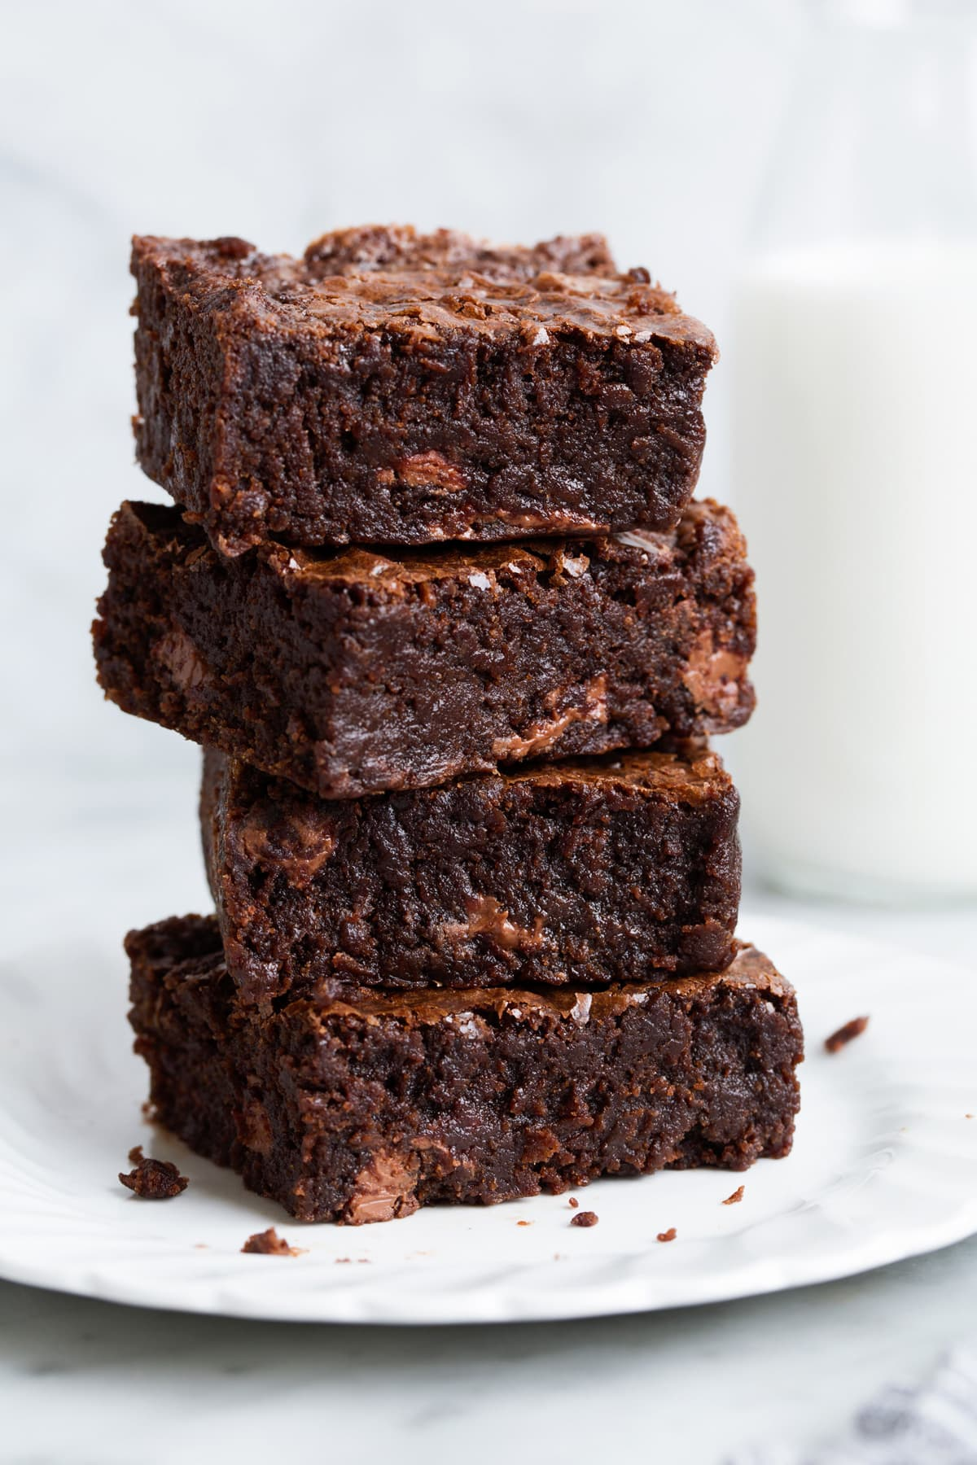

# Desserts

|  |  |
| --- | --- |
| Brownies | |
| SERVES 4 – 5 | 1 – 2 HRS | |
| **INGREDIENTS:** | **INSTRUCTIONS:** |
| 1 cup butter (melted) | 1. Preheat the oven to 175 C°. Grease a 9x13-inch pan. 2. Combine the melted butter, sugar, cocoa powder, vanilla, eggs, flour, baking powder, and salt. Spread evenly. 3. Bake in preheated oven for 20 to 30 minutes, until a toothpick inserted in the centre is not wet. Cool on wire rack. |
| 2 cups white sugar |
| $\frac{1}{2}$ cup cocoa powder |
| 1 tsp vanilla extract |
| 4 eggs |
| 1 $\frac{1}{2}$ all-purpose flour |
| $\frac{1}{2}$ tsp baking powder |
| $\frac{1}{2}$ tsp salt |

|  |  |
| --- | --- |
| Biscuits | |
| SERVES 4 – 5 | 1 – 2 HRS | |
| **INGREDIENTS:** | **INSTRUCTIONS:** |
| 1 cup (226g) unsalted butter, softened | 1. Preheat the oven to 175 C°. 2. In the bowl of an electric mixer cream together butter, sugar and salt until combined. 3. Mix in egg yolks and vanilla. 4. Add flour and mix until crumbly then add in 2 tsp milk, if needed add in another 1 - 2 tsp milk for a more pipe-able consistency - add as little as possible for less spreading though. 5. Transfer to a 16-inch piping bag fitted with a large open star tip. Pipe dough into rounds onto two ungreased baking sheets. 6. Bake one sheet at a time in preheated oven until golden brown on bottom, about 12 - 16 minutes. 7. Let cool on baking sheet 5 minutes then transfer to a wire rack to cool completely. |
| 2/3 cup (140g) granulated sugar |
| 1/4 tsp salt |
| 2 large egg yolks* |
| 1 1/2 tsp vanilla extract** |
| 2 cups (283g) all-purpose flour (scoop and level to measure) |
| 2 - 4 tsp milk |